A given work of art should be compared not to any isolated locus but to a river's catchment, complete with its estuaries, its many tributaries, its dramatic rapids, its many meandering turns and, of course, also, its several hidden sources. To give a name to this catchment area, we will use the word trajectory.

HIST3812

January 10th 2018

“If we stop interpreting, if we stop rehearsing, if we stop reproducing, the very existence of the original is at stake. It might stop having abundant copies and slowly disappear.”

-what about those people who cannot visit Paris every day to visit the Louvre?

-what about authenticity? Who is looking for authenticity?

**-collective memory**

-but without these copies, would we value the original as much?

What does originality mean?

“The original although only in the name”

The value of replications..

Why are these objects replicated?

The “secondary”

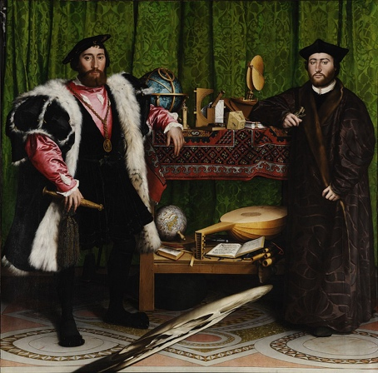

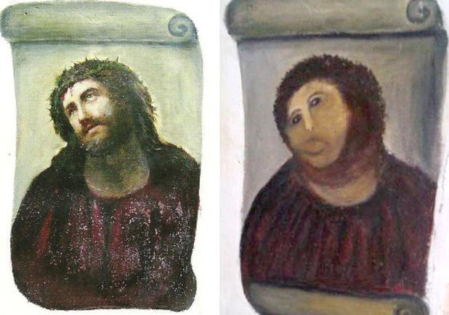

[Botched Restoration of Jesus Fresco Miraculously Saves Spanish Town](https://news.artnet.com/art-world/botched-restoration-of-jesus-fresco-miraculously-saves-spanish-town-197057)

Subjectivity, reproductions with small defects are worth more than the original(ex: star wars figures, rare coins, stamps, defect bank notes)

Mechanical reproduction of art gives more access to the masses. Original vs. cheap reproduction. An artist’s intention of their piece loses meaning as time goes on. The audience may perceive the piece of art entirely different than the artist or fellow audience members.

Censorship in restoring original paintings.

The public is an examiner, but an absent-minded one.

Objects have a use biography - used and represented different ways throughout its life.

**Programming is Forgetting**:

<http://opentranscripts.org/transcript/programming-forgetting-new-hacker-ethic/>

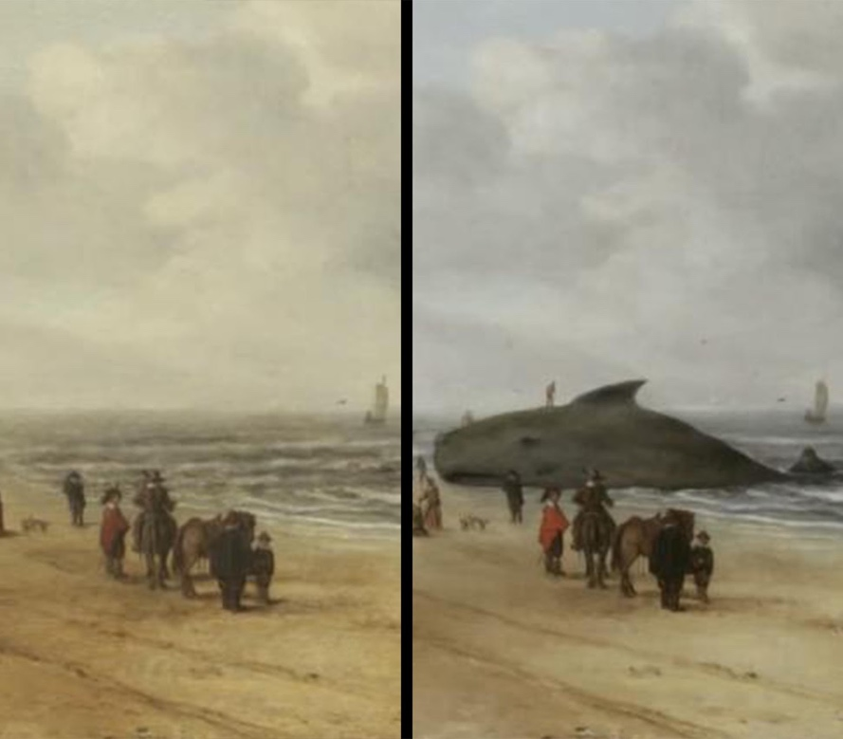

**01/24/18**

* The aims of the ACCORD project looked beyond inclusion to examine the opportunities and implications of digital visualisation technologies for community engagement and research
* In particular, I want to understand what seems like a paradox between the persisting idea of the *objectivity of recording heritage* using (*passive*) these technologies and the actual experience and performance of the *creative process of making* when *engaging (active)* with these technologies
* Not in keeping with art-historical tradition, in the field of digital visualization the artists and traces of making are hidden from view - it is almost as if acknowledgment of human hands would break the illusion of 'reality'
  + But, paradoxically, when we look, despite his attempts to hide behind the machine, we are always aware of the personality who created the work.
* While in the context of early 20th-century thought there was perhaps some comfort in finding solace in the scary and still emergent omnipresence of machines, arguably in our 21st-century world saturated with machines it is precisely this pursuit for objectivity that is the barrier to meaningful mass engagement with digitally produced realistic visualizations.
  + Fast forward 100 years, at the peak of the machine age and immediately after World War Two, painting persisted despite Benjamin's proclamation and abstract expressionism was born, epitomized by artists such as Arshille Gorky and later Jackson Pollock.
  + This is because in the end we value human creativity above machines and we seek the cult of the individual, that private encounter.

[**http://www.regard3d.org/**](http://www.regard3d.org/)

**ACCORD PROJECT**

- Thoughts on the heritage of the project:

- How the process changed to the final product. (What they thought/planned vs what came out)

- Effect of the object on audience interpretation vs how the creators intended it.

Process vs. product - intangible vs. tangible

-how much of the process does the audience need to know about to create the “proper” context for appreciating the product?

In the process of creating something, does it change the story of the object? And are you indirectly changing the story? How can the change of context or environment change the object and its perceived meaning?

Divorcing an object from its context

Why are we reproducing something?

How did the community interact and how did it change them?

Stated that they weren’t ready to take the most professional and objective picture. Acknowledge own limits. Value was in the process of creating the object and connecting with its heritage.

Aura - cult of originality for so long, but there was a time when the copy was what was valued (plaster casts of ancient architecture) - where is the aura in both?

* Now movement towards valuing the original object without context (simply because it’s the original)
* Preserving the form but not the material - sometimes the material is just important as the form - the material can inform the form and have its own connotations

Context of production, display, materials

* Can be political - will see this later

Idea of performance

Artistic value vs. historical value

* Artistic - its ability to inspire future work, change doesn’t diminish the object’s value

Continually remaking an object for the needs of the present

**Top Tips of 3D Models**

* Using computers is easier than your phone
  + So take photos and upload to Underhill computer???
  + Yes, or you can use Regard 3D at home
    - There are more settings you can play with when using the computer
* Make sure to get rid of the background of your pictures
  + Tips on how???
    - I used paint and just erased it, a bit time consuming, but it works
    - Gimp is a free *Photoshop* that will allow you to remove the background
* Use highest resolution image possible

-Work with it and see what you can do, the more work you can get done in Regard3D is less work for you when it comes to editing.

* Great lighting

**3D modelling applications**

- Gimp

- vectr

- sketchup

**Computational Creativity**

**Remixing History – 02/05/2018**

* Things can be remixed and stuff
* The forces that shape digital objects and all that is digital and stuff and whatever, read the article I guess?
* Meshmixer, Meshlab allows you to blend 3D models
  + Module 2
  + What other models can I find that can be meshed?

*Monday Feb 5th, 2018 -* ***Module 2: History is a Remix***

***https://shawngraham.github.io/presentations/3812-feb5.html***

* Sometimes the remix shows something different (perspective) about the person creating the work

-in fake trailers like “Scary Mary”, the elements already present in Mary Poppins are simply rearranged to bring out a new aspect of the film we may not have observed in its original presentation

Watling Street

·         Remixing archeological data in a way that makes certain realities more apparent. We can understand the economic prosperity (/disparity) and distribution of roman coins in Britain through SOUND.

·         It is a remix of someone else’s code

-some “DJs” work across mediums, taking data and turning it into music

Sometime it is the CODE and the underlying data that is remixed

Sometimes remixing does more harm than good - Daniken’s belief that the ancients had help from aliens. It is a form of racism and reveals more about the people that made it.

[Lawerence Lessig - Creative Commons (Wiki Bio)](https://en.wikipedia.org/wiki/Lawrence_Lessig)

[Aaron Swartz - Internet Hacktivist (Wiki Bio)](https://en.wikipedia.org/wiki/Aaron_Swartz)

Is it compelling or truthful?

Remixing of plaques made by the Department of Recreation and Conservation

- Original: Fur, Gold, and Cattle: Founded in 1812, Fort Kamloops stood at a natural cross roads. For 50 years it remained the focus of an inland fur empire until the roaring mining boom of the 1860’s. Ranchers, with cattle and horses, replaced the miners. They settled, and stayed, to see two railways bring prosperity anew to this land of sagebrush, sun, and great rivers.

- Remix: Salmon, Copper and Elk: For millennia before European arrival, Tk’emlups was home to a stable and diverse local economy. Secwepemc commercial trade routes, resources and relationships allowed the fur trade to thrive, and Fort Kamploops men survived on meat & fish sold by local harvesters. Ranching, railways and settlers changed the balance: traditional lands were alienated, cattle disease decimated elk populations, & punitive, racist laws denied prosperity to Secwepemc residents.

[Infinite Looper](http://www.infinitelooper.com/)

[Infinite Jukebox](http://infinitejukebox.playlistmachinery.com/)

Remixing vs. Mixing

- The ‘re’ part is problematic

- A mix brings something new into being, something new from the source materials that was always latent

Deformance  & Interpretation (McGann and Samuels)

“reading backwards ‘short circuits’ our usual way of reading a text and ‘reinstalls the text – any text, prose or verse – as a performative event, a made thing’ (Samuels & McGann 30). Reading backwards revitalizes a text, revealing its constructedness, its seams, edges, and working parts” – Mark Sample

Deformed Humanities – a humanities born of broken, twisted things. And what is broken and twisted is also beautiful, and a bearer of knowledge.

- Humpty Dumpty broke and something better came of it

- “the deformed work is the end, not the means to the end.”

- Deformance vs. deformation